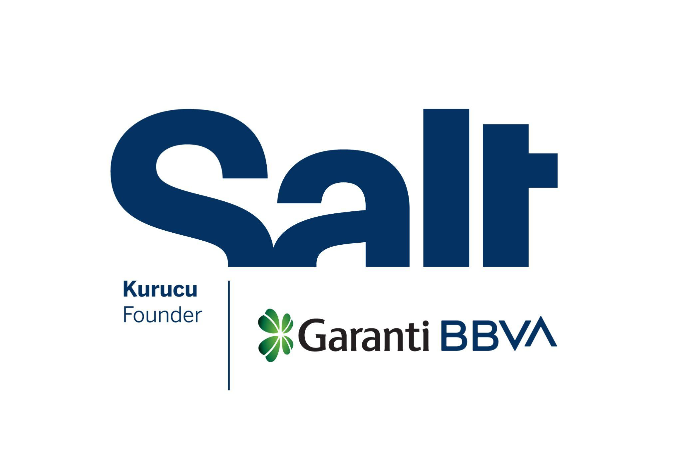

Press Release
January 29, 2026

Epipe
Güneş Terkol

January 30 – March 8, 2026
Salt Galata

Güneş Terkol’s exhibition “Epipe,” the first of two projects supported in 2025–2026 as part of the Salt Artistic Research and Production Grant Program, in collaboration with the BBVA Foundation, opens at
Salt Galata.

Salt presents Epipe by Güneş Terkol, one of the two recipients of the second edition of the Salt Artistic Research and Production Grant Program, organized in collaboration with the BBVA Foundation.

Epipe is the culmination of an oral history and archival research project that Terkol has been working on with her mother, Elmira Terkol, since 2002. The artist weaves together earlier and newly produced works with materials distilled from this research, which traces the multi-stage migration of the Kazan Tatars beginning in the late 19th century, from Russia to China and eventually to Türkiye. Combining drawing, animation, and stitching, she develops a layered audio-visual narrative around migration routes, family recollections, and exchanges across geographies and generations.

During the preparations for the exhibition over the past year, a series of research trips took place, including visits to the Forum of Tatar Women in Kazan and the Sabantuy Festival in Eskişehir. These encounters involved listening to numerous migration stories, conducting video interviews, and bringing family heirlooms and photo albums out of chests. The final stage of this research was a sewing workshop held at the Kazan Culture and Solidarity Association in Ankara, with the participation of Tatar women who had migrated from China. As in other workshops led by the artist with women across different countries, this process offered space for personal stories to take shape within a collective narrative. Participants’ reflections on migration, belonging, and family memory were woven into fabrics and transformed into a banner, accompanied by traditional Tatar songs.

Epipe takes its name from a well-known Tatar folk song that depicts a dancing female figure, evoking both the memory and vitality of a community that has witnessed several historical shifts, from wars and occupations to economic crises and regime changes. Modes of production, forms of coexistence, and embodied practices preserved through forced displacements coalesce into a repertoire of intergenerational experience, labor, and resilience.

The exhibition will be ​​on view in the Mastercard Exhibition Hall at Salt Galata from January 30 until March 8. Public programs accompanying the exhibition will be announced soon. For more information: saltonline.org.

The exhibition is realized with the contributions of Türk Tuborg A.Ş. and Jotun.

Founded by Garanti BBVA, Salt is a not-for-profit cultural institution engaging in research, exhibitions, publications, web projects, and public programs at the intersections of visual practices, the built environment, social life, and economic history.

The BBVA Foundation, as the corporate social responsibility of the BBVA Group, is committed to advancing society by promoting and disseminating knowledge through research-based, artistic, cultural, and scientific projects.

Media Relations
Zeynep Akan
zeynep.akan@saltonline.org
+90 212 334 22 45

