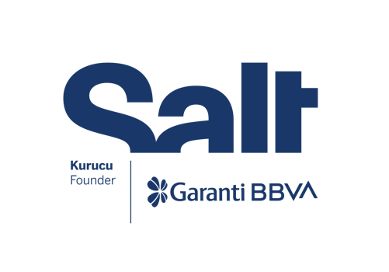

Press Release
September 14, 2022

“The 90s Onstage”

September 15, 2022 – April 9, 2023
Salt Beyoğlu | Salt Galata

Salt’s new exhibition, “The 90s Onstage,” exploring aspects of the stage and performance in Turkey’s 1990s culture scene,
opens on September 15.

Founded by Garanti BBVA, Salt’s new exhibition The 90s Onstage chronicles stage and performance art in Turkey’s cultural scene during the 1990s. Examining the practice of performance in relation to society, economy, the street and politics, the exhibition presents a potpourri of cultural history while addressing the individual and collective initiatives of artists and designers. It assembles archival materials and introduces a variety of production styles, ranging from live performances to video clips and television programs.

The 1990s marked a period of major social, political, and economic shifts in Turkey. Meanwhile, the country settled on a new line of cultural and economic circulation in addition to a period of dynamism that contrasts with the darkness that began as the boundaries of freedom expanded in the fields of culture, art, performance, and entertainment, particularly in Istanbul. With the help of private television and music channels opening one after the other, pop culture enjoyed an unprecedented rise. It was also a time when Turkey’s art scene foregrounded the “interdisciplinary” concept. Integrating a wide range of disciplines, the medium of performance and its experimental nature offered a progressive ground for artists.

Examining performance works produced during this decade, The 90s Onstage presents multifaceted insights into the history of the arts, culture, and entertainment. It traces the intersections between popular culture and a diverse range of performances that gained visibility in parks, bars, historical landmarks, and abandoned sites, creating unlikely connections and contributing to a broader understanding of the “stage”.

Salt Beyoğlu features works by artists including Aydın Teker, CANAN, Esra Ersen, Halil Altındere, Hüseyin Katırcıoğlu, Köken Ergun, Moni Salim Özgilik, Özlem Günyol & Mustafa Kunt and Taner Ceylan. An array of productions expanding on the relationship between art and the street are accompanied by photographs, posters and correspondences from selected events such as the Seretonin and Genç Etkinlik [Youth Action] exhibitions as well as the Assos Performing Arts Festival. The works of artists Burak Delier and Mehmet Sander are presented at Salt Galata, together with a performance piece by Ceylan Öztrük.

The 90s Onstage can be viewed free of charge until February 12, 2023 at Salt’s Beyoğlu and Galata locations. In parallel with the exhibition, a website comprising comprehensive archival material related to selected performances will be launched with the support of Zorlu Holding and Zorlu Performing Arts Center’s Digilogue. Music events and DJ performances organized within the scope of the exhibition are supported by Türk Tuborg A.Ş., and Leman Sevda Darıcıoğlu’s performance by monoco.io.

The 90s Onstage is programmed by Amira Akbıyıkoğlu in collaboration with Emirhan Altuner (Design and Production) and Gül İçel (Project Assistant) from Salt, together with researcher Mine Söyler. An accompanying public program will be announced at saltonline.org and Salt’s social media channels.

Participants
Adnan Tönel, aeigis, Ali Emir Tapan, Arhan Kayar, Asiye Cengiz, Atilla Özdemiroğlu, Aydın Teker, Ayşe Draz, Bedri Baykam, Burak Delier, Cana Dölay, CANAN, Ceylan Öztrük, Çağatay Karaçizmeli, Ekim Acun, Esra Ersen, Genco Gülan, Geyvan McMillen, Gürel Yontan, Ha Za Vu Zu, Halil Altındere, Hazal Halavut, Hüseyin Katırcıoğlu, İbrahim Akyürek, Komet, Köken Ergun, Kumpanya, Lamia Karaali, Leman Sevda Darıcıoğlu, Levent Öget, Mehmet Güleryüz, Mehmet Sander, Mete Özgencil, Moni Saim Özgilik, Nadi Güler, Nur Akalın, Nurgül Polat, Orhan Atasoy, Orhan Cem Çetin, Ömer Ahunbay, Özlem Günyol & Mustafa Kunt, Pilvi Takala, Raife Polat, Selçuk Gürışık, Selva Daşdemir, Sevi Algan, Simge Burhanoğlu, Şule Ateş, Taldans, Taner Ceylan, Tuğçe Tuna, Umur Turagay, Vahit Tuna, Yeşil Üzümler, Zişan Uğurlu

The 90s Onstage is organized as part of L’Internationale’s Our Many Europes program.



Our Many Europes is a four-year program initiated in 2019 by the museum confederation L’Internationale and its partners, and co-funded by the Creative Europe Programme of the European Union. L’Internationale gathers seven major art institutions: Moderna galerija (MG+MSUM, Ljubljana, Slovenia); Museo Reina Sofía (Madrid, Spain); MACBA Museu d’Art Contemporani de Barcelona (Barcelona, Spain); Museum van Hedendaagse Kunst Antwerpen (M HKA, Antwerp, Belgium); Muzeum Sztuki Nowoczesnej w Warszawie (Warsaw, Poland); Salt (Istanbul, Turkey), and Van Abbemuseum (VAM, Eindhoven, Netherlands), which team up with HDK-Valand Academy (Gothenburg, Sweden), and the National College of Art and Design (NCAD, Dublin, Ireland).

Salt is founded and supported by Garanti BBVA.

Media Relations
Zeynep Akan
zeynep.akan@saltonline.org
+90 212 334 22 45

Images:
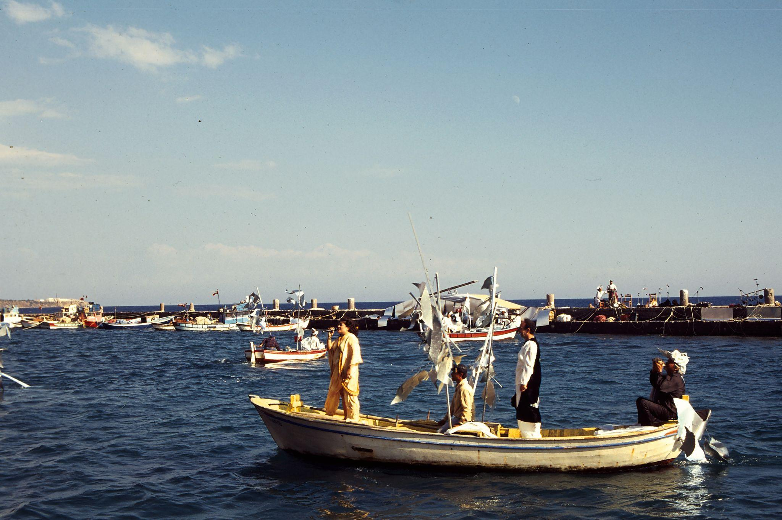
Ya Da Tiyatro, Safo [Sappho]
Assos Performing Arts Festival, 1996
Photo: Raife Polat

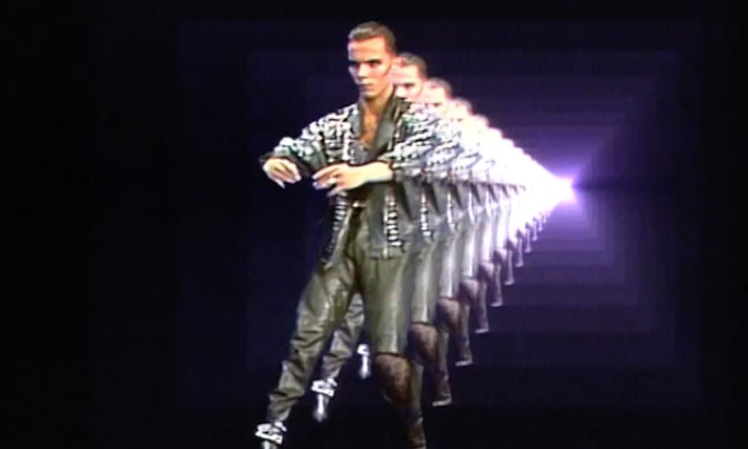
Still from Mehmet Sander’s performance for a TV show, c. 1986

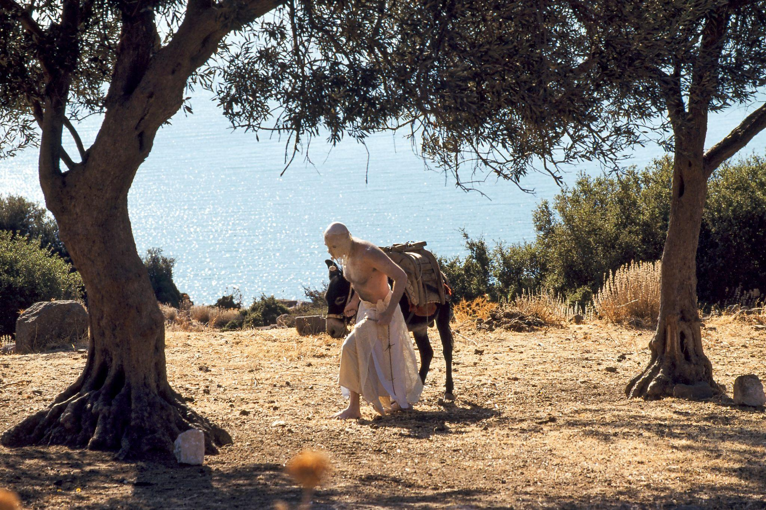
Still from Chapel of Change’s (Mary Salem and Rainsford) performance The Sleeping Water
Assos Performing Arts Festival, 1997
Photo: Nurgül Polat

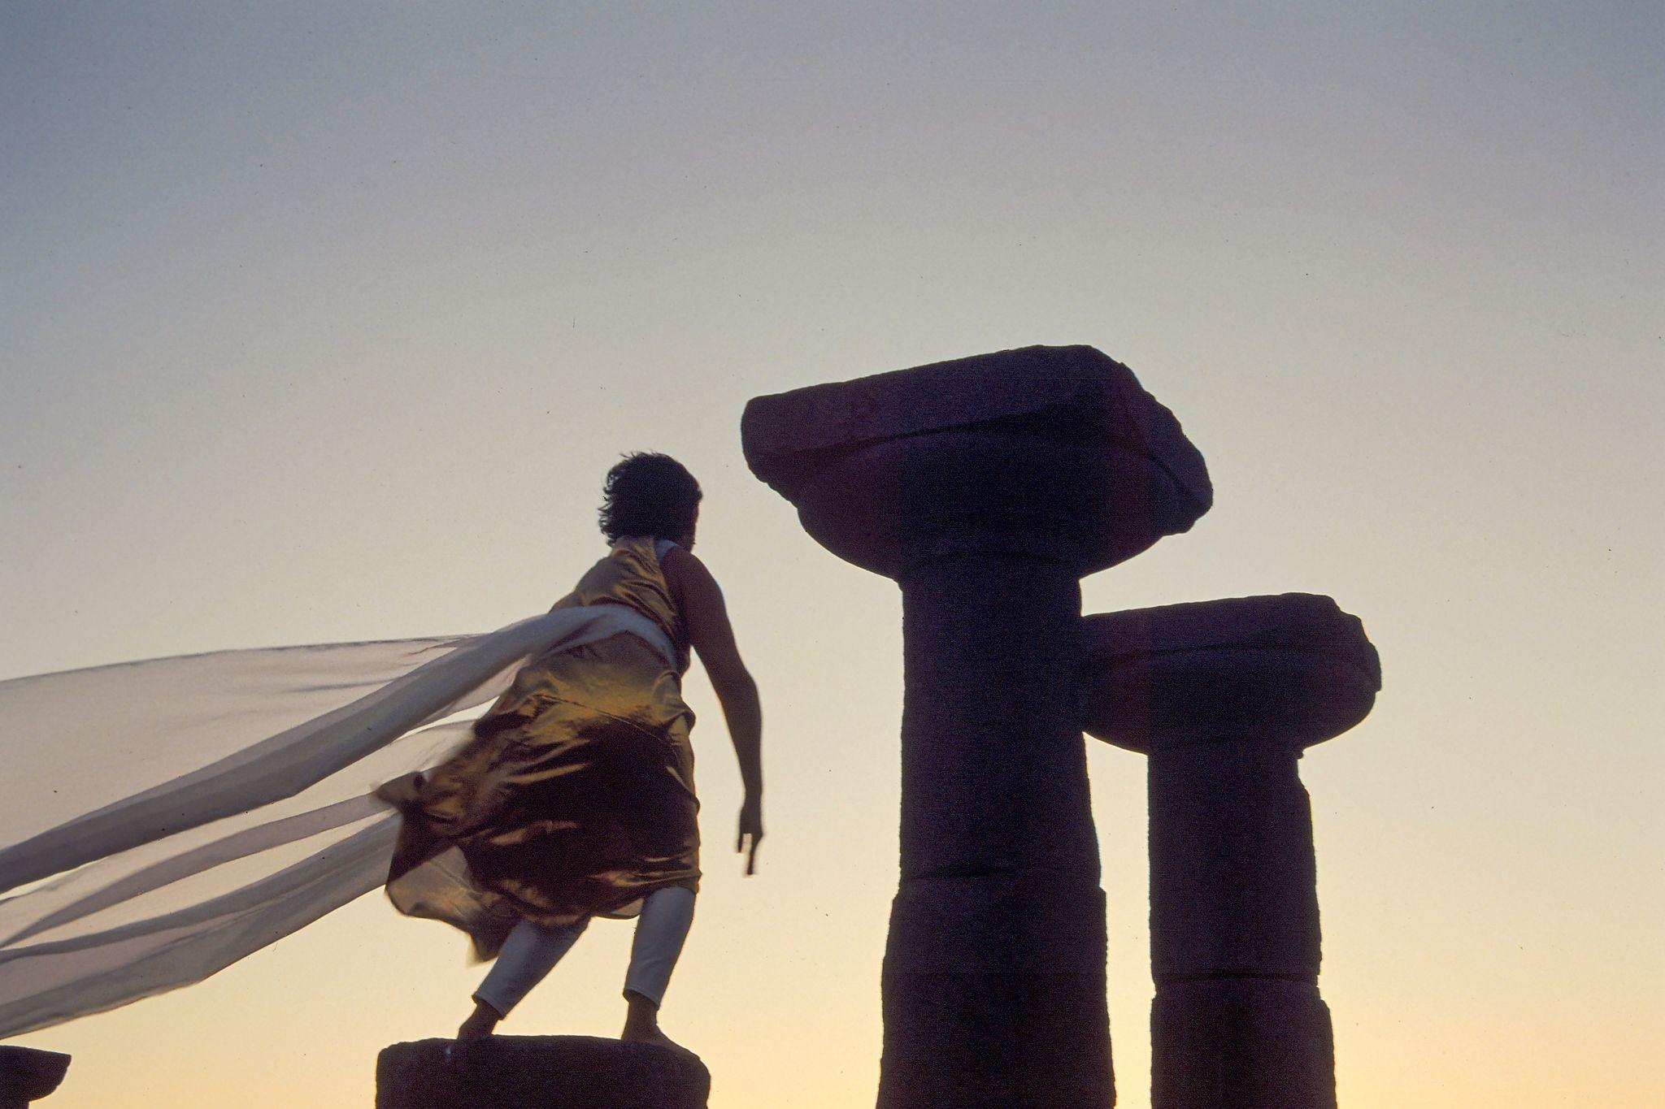
Still from Diana Marto and Hope Coffin’s performance at the Temple of Athena
Assos Performing Arts Festival, 1997
Photo: Nurgül Polat

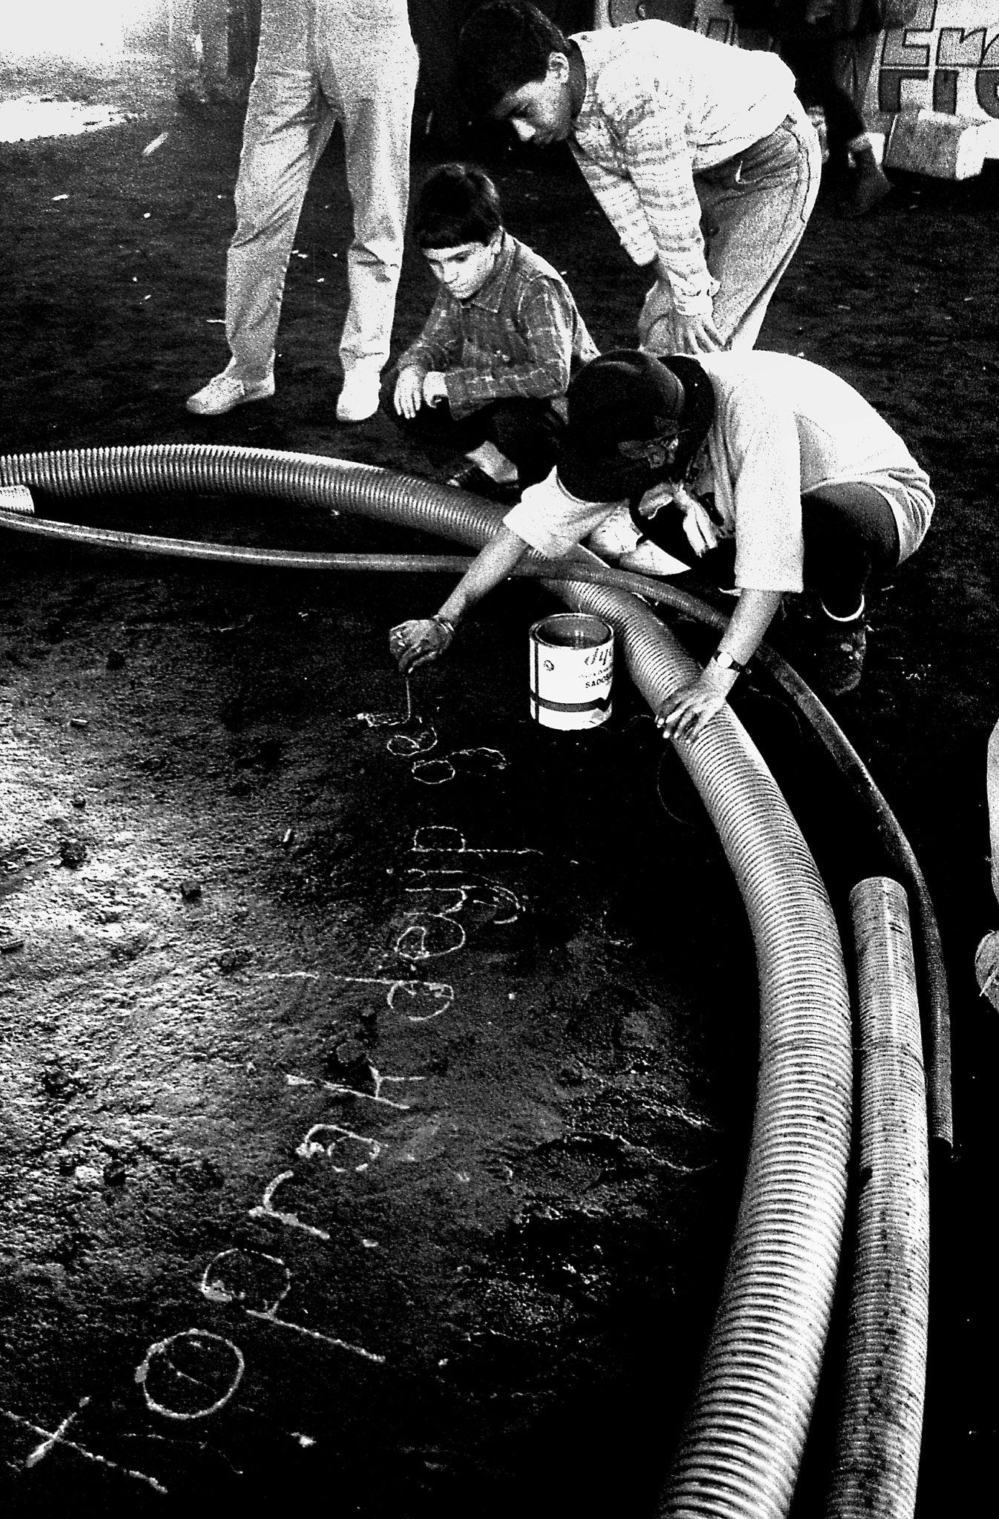
Photograph from İbrahim Akyürek’s series
Gazhaneler’de Şenlik Var [Festival at Gasworks]
Seretonin II exhibition, Yedikule Gasworks, 1992
Courtesy the photographer

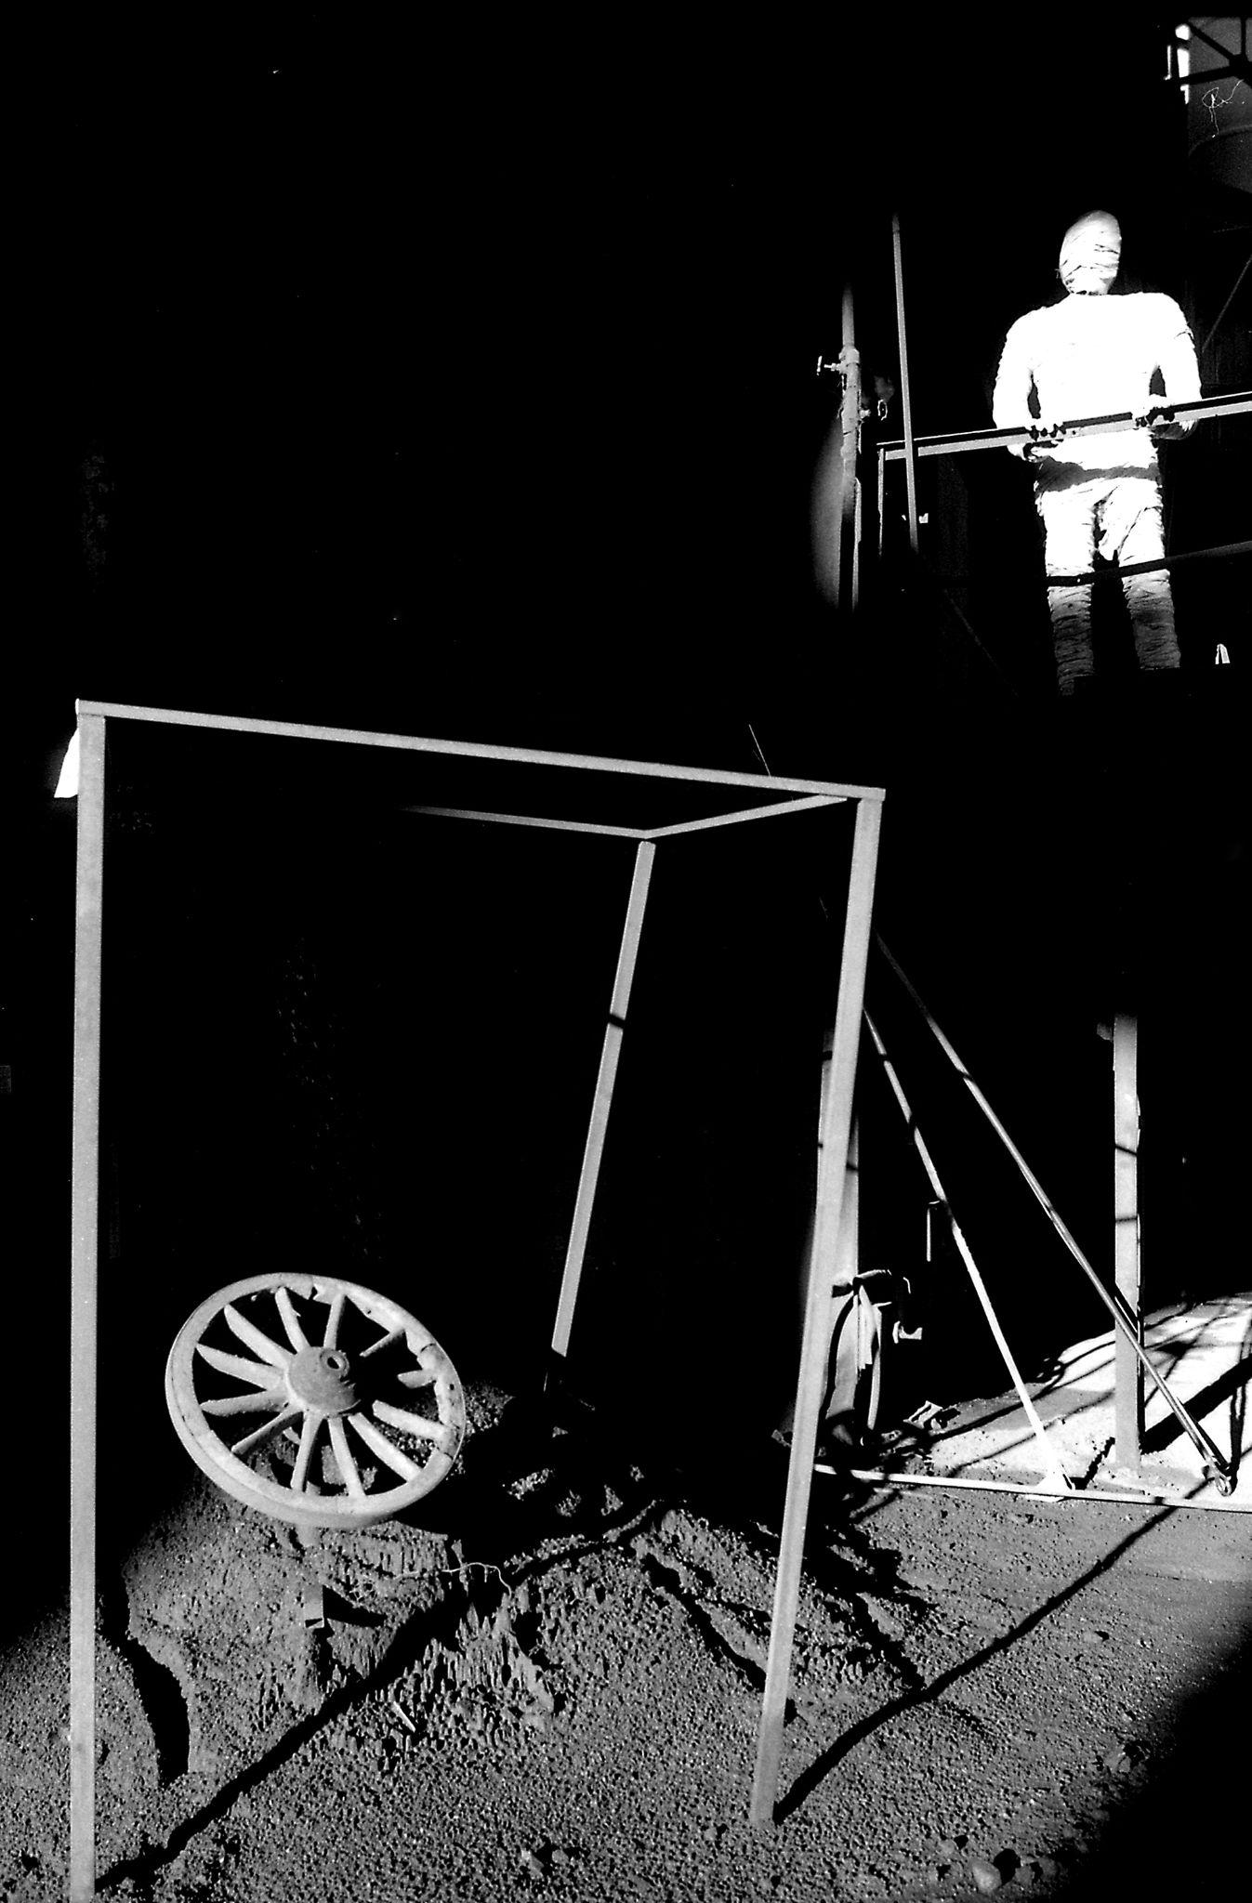
Photograph from İbrahim Akyürek’s series
Gazhaneler’de Şenlik Var [Festival at Gasworks]
Seretonin II exhibition, Yedikule Gasworks, 1992
Courtesy the photographer

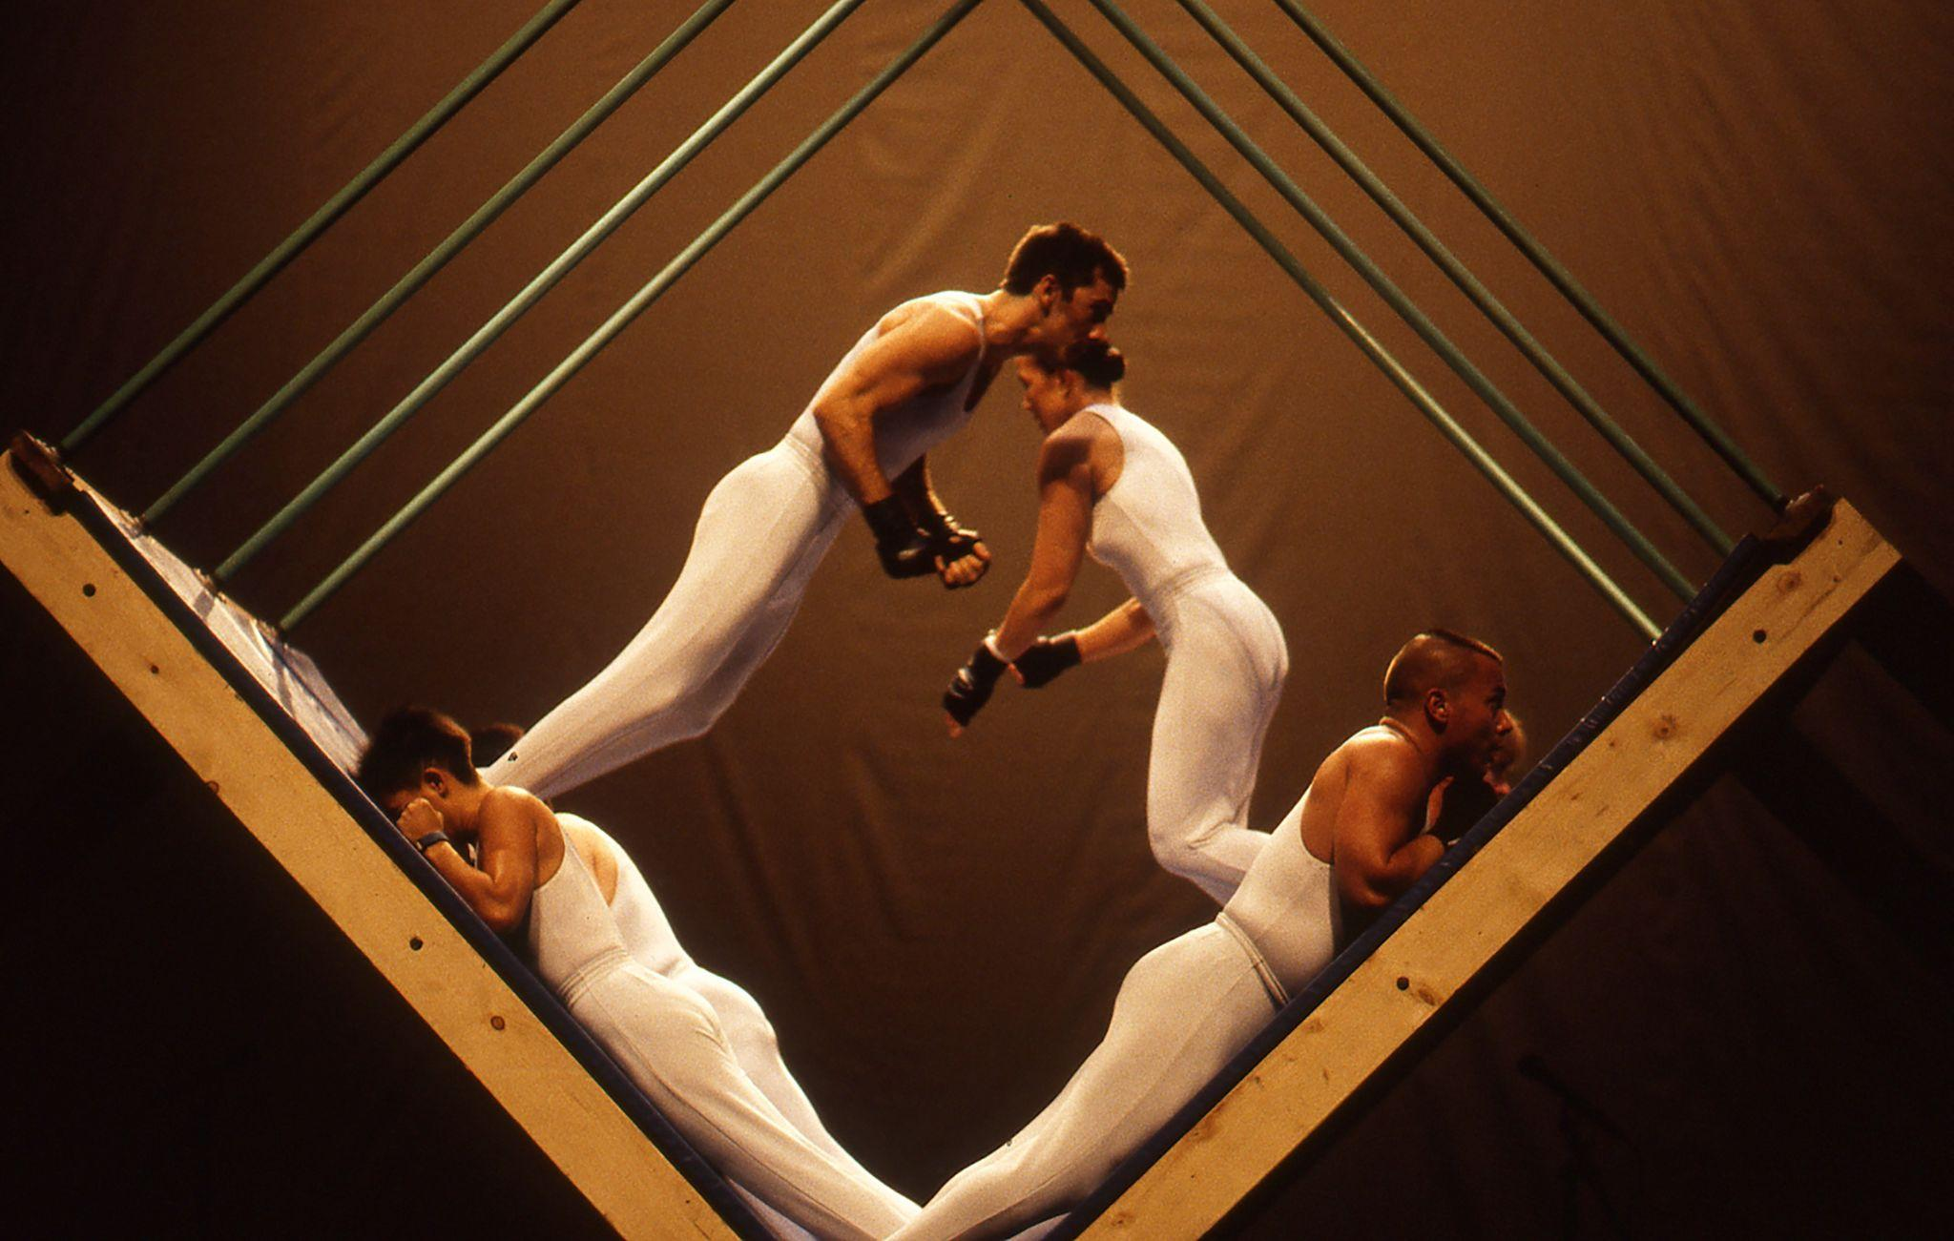
Mehmet Sander Dance Company’s Infinite Space / Controlled Space (1994)
as part of their performance at the Atatürk Kültür Merkezi (AKM; Atatürk Cultural Center)
The 24th International Istanbul Music Festival, 1996
Courtesy IKSV archives

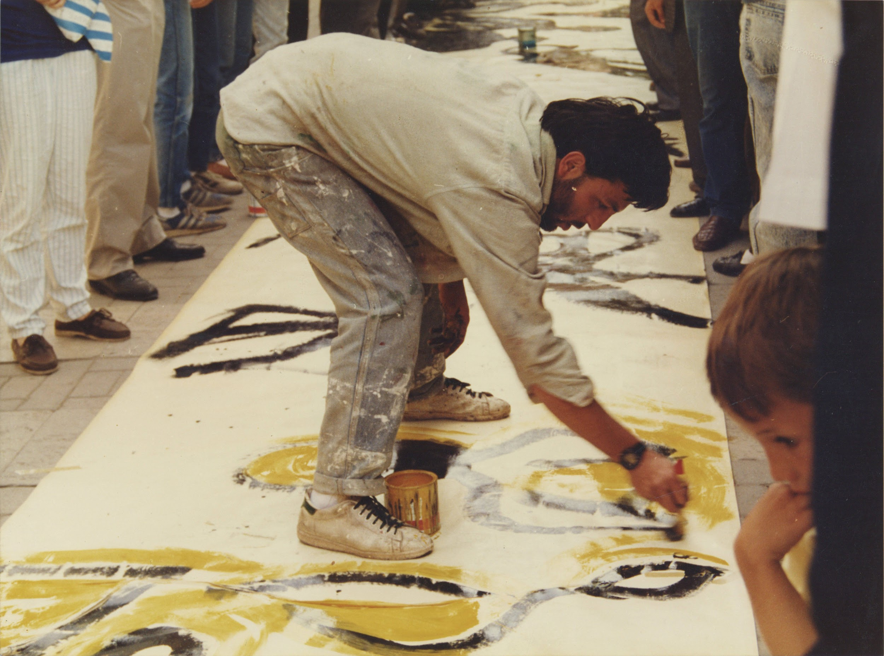
Still from Sakarya Destanı [The Legend of Sakarya] by Moni, Ankara, 1988
Salt Research, Moni Salim Özgilik Archive

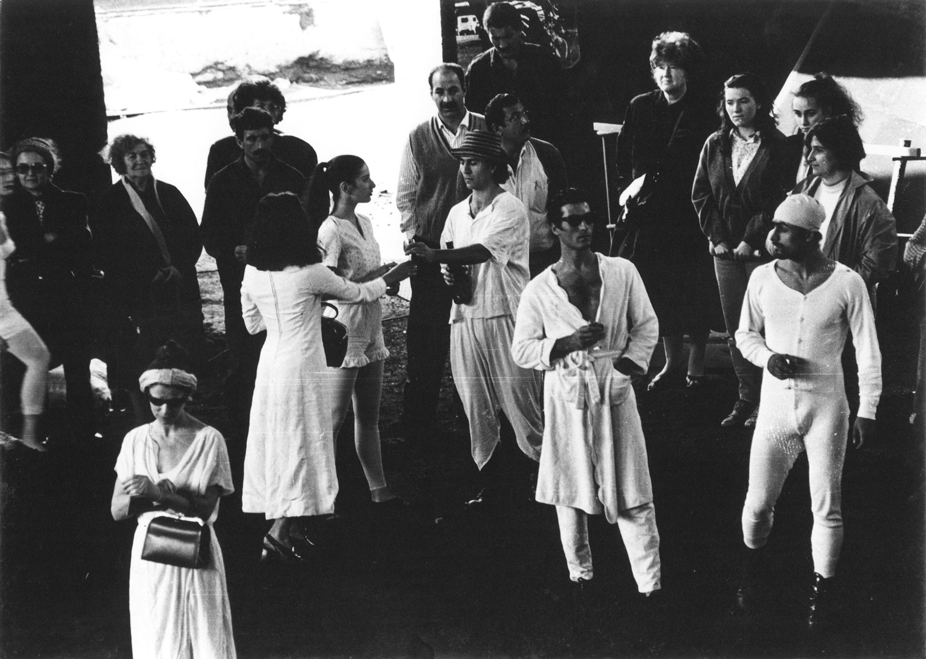
Still from Köm-ür choreographed by Aydın Teker as part of Seretonin II, 1992
Courtesy the artist

The 90s Onstage
Public Program

- Thursday, September 15, 19.00-20.00
Performance
Oyun B
Ceylan Öztrük
Salt Galata, Floor 1
- Sunday, September 18, 11.00-18.00
Performance
Angelus Altera
Leman Sevda Darıcıoğlu & Natis fka. Hasan Aksaygın
Salt Beyoğlu, Floor-1 & Kitchen
- Tuesday, October 4 & Wednesday, October 5, 12.00-17.00
Open Rehearsal
GalataPerform
Salt Galata, Workshop II-III
- Friday, October 21, 19.00-20.00
Performance
Invitation to the Dance: Private Television Channels and Democratized Performances
Ekim Acun
Salt Beyoğlu, Walk-in Cinema
- Friday, October 21, 20.00-21.30
DJ Performance: Q-Bra
Salt Beyoğlu, Kitchen
- Saturday, October 22 & Sunday, October 23
Movement Workshop with Mehmet Sander
Salt Galata, Floor 4
- Friday, November 18, 19.00
Performance
Ha Za Vu Zu
Salt Beyoğlu, Walk-in Cinema
- Saturday, November 19 & Sunday, November 20, 11.00-18.00
Saturday, November 26 & Sunday, November 27, 11.00-18.00
Open Rehearsal
ÇATI Çağdaş Dans Sanatçıları Derneği
Salt Galata, Workshop II-III

