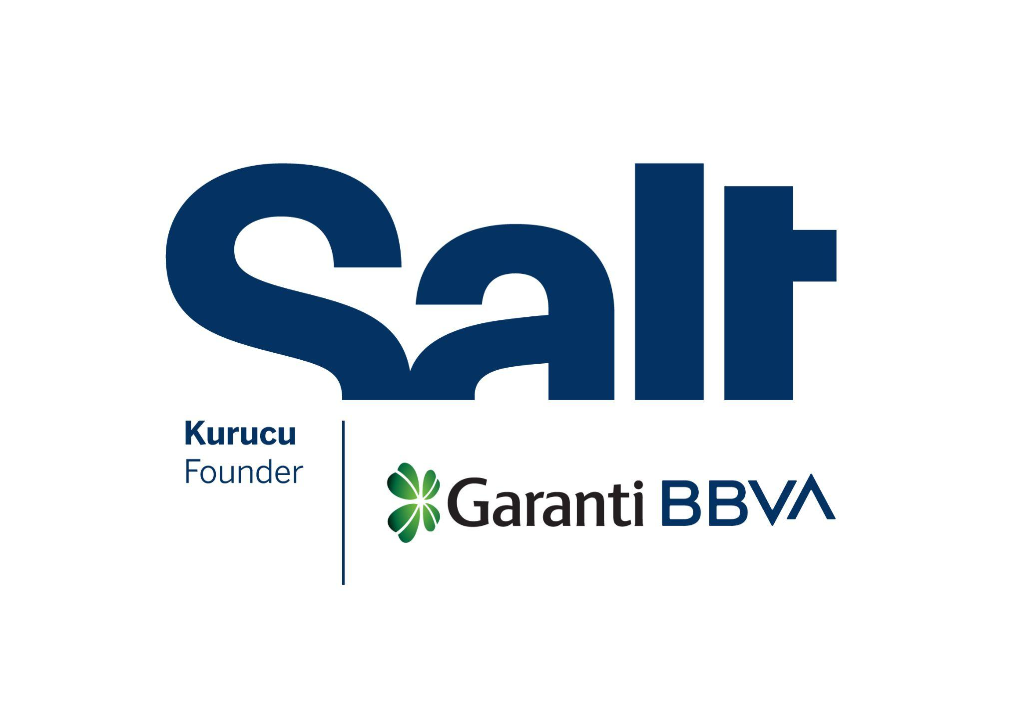

Press Release
September 19, 2025

New Exhibition:
We’ve Been at the Tapestry Studio Since the 90s

September 19, 2025 – March 1, 2026
Salt Beyoğlu

The exhibition “We’ve Been at the Tapestry Studio Since the 90s” is now on view at Salt Beyoğlu.

Founded by Garanti BBVA, Salt’s new exhibition, We’ve Been at the Tapestry Studio Since the 90s, focuses on the Tapestry Studio within Mimar Sinan Fine Arts University’s Department of Painting and its approach to art education. While exploring its relationship with everyday life, the exhibition also highlights the potential of creative dissent and collective production. Tracing the physical and conceptual connections meticulously built since the founding of the studio, it presents a collage of collaborative and individual works, archival materials, and testimonies of artists who have passed through this space.

The production of contemporary art and the discussions it sparked gained momentum in Turkey during the 1990s, establishing links with social and political movements. Their place within the academic curricula, however, remained limited. Upholding its long-standing traditions, MSGSÜ remained distant from the diverse practices flourishing particularly in Istanbul. Yet, dissenting voices gradually began to be heard, albeit few and far between. The Tapestry Studio has carved out a unique position both within and outside the institution. Combining carpet weaving education with contemporary art, it has embraced a pedagogical approach rooted in “learning together” and offered programs open to everyone. It created an exceptional model that dismantled the gendered hierarchies and entrenched bureaucracies inherent in academia, bringing together students, artists, guests, and cultural workers around the same table. Most importantly, this model did not exclude the street.

The Tapestry Studio was established in 1976-77 as a practice studio under the direction of painter and academic Zekai Ormancı (1949-2008), with the initiative and encouragement of painter and academic Özdemir Altan. It was always described as the “laid-back studio” and even taken lightly due to the traditional connotations of its name. It was the last choice for some students, while others turned to it so that their time in the practice studio wouldn’t interfere with their own painting. However, this relaxed environment would eventually yield unexpected outcomes.

In 1992, visual artist and academic Gülçin Aksoy (1965-2024) was appointed as an assistant at the Tapestry Studio. Together with a group of students and colleagues, she sparked a dynamism that gradually transformed the studio from the late 1990s onward. This synergy spilled out of the studio door—which Aksoy kept open both physically and conceptually—first into the university corridors and then into Istanbul’s contemporary art scene. The studio’s production model multiplied, diversified, and expanded through the relationships it forged with independent art initiatives, feminist circles, and interdisciplinary collectives in the city during the 2000s.

“You can weave a carpet, and you can weave an idea”

Yarn and weaving have functioned not only as materials and techniques, but also as enduring modes of thought and relation at the Tapestry Studio. Instead of practicing insular art education, Aksoy embraced the approach that “you can weave a carpet, and you can weave an idea,” intertwining traditional carpet weaving practices with performance and everyday life. Together with students who thought, interpreted, and took action alongside her, she sought ways to develop conceptual insights from the (horizontal) weft and (vertical) warp of the loom, playing with language, words, and sounds. The Tapestry Studio thus became an “open workshop,” no longer confined to a syllabus and attuned to interests beyond the curriculum.

The studio addressed a whole host of issues—from the inertia of art academies and patriarchal social structures to state apparatuses and institutional aesthetics—mixing subtle mischief with playful teasing. Never losing sight of current events, the studio gave rise to the artist collective AtılKunst (2006-2013), the performances Garip Bir Pandik 1 [A Strange Goosing 1] (Tapestry Studio, 2011) and Garip Bir Pandik 2 [A Strange Goosing 2] (Rumeli Han, 2012), the exhibition 3/1 (Tapestry Studio, 2013), and numerous projects ranging from fanzines to stitching, all of which emerged in response to recurring issues.

Drawing inspiration from the studio’s well-known motto—“same direction, different pedal; different direction, same pedal”—the exhibition sheds light on the history of shared practices and individual pursuits within the studio. It unravels the threads of a community that spans from the past to the present, as it traces an intergenerational kinship of production.

We’ve Been at the Tapestry Studio Since the 90s is on view at Salt Beyoğlu until March 1, 2026. Public programs accompanying the exhibition begin with Şiva Canbazoğlu’s performance a tangible blue on Wednesday, October 1 at Salt Beyoğlu, Floor 2. For more information: saltonline.org.

About the exhibition title: The slogan “We’ve Been at the Tapestry Studio Since the 90s” originated from a dream had by artist and academic Duygu Sabancılar, who was part of the Tapestry Studio between 2009 and 2015. It was embroidered onto fabric by Gülçin Aksoy and the studio’s students and transformed into a banner. This banner was first presented in the exhibition Buradan Nereye? Kolektif Sanat Pratikleri [Where Do We Go From Here? Collective Art Practices] (Istanbul Bilgi University, 2016).

The exhibition is realized with the support of Spot Projects and with contributions from Türk Tuborg A.Ş., Asya International Movers, Bankerhan Hotel, Eureko Sigorta, and Jotun Boya.

* * *

Program: Amira Akbıyıkoğlu, Eylül Şenses, Tapestry Studio constituents
Research: Betül Bolat
Exhibition Design and Production: Emirhan Altuner
Editor: Ezgi Yurteri
Translation: Paul Osterlund, Merve Pehlivan, Nâzım Hikmet Richard Dikbaş
Video Editing: Metean Bars, Gizem Bayıksel
Exhibition Assistants: Yeraz Kortun, Naz Tekay, Ecem Yerman
Installation: Burak Bodur, Tansu Demirel, Eray Özcan, Fiksatif, 3T Reklam
Communication Design: Wiseslang
Acknowledgments: Everyone who has crossed paths with the Tapestry Studio

Salt is founded and supported by Garanti BBVA.

Media Relations
Zeynep Akan
zeynep.akan@saltonline.org
+90 212 334 22 45

