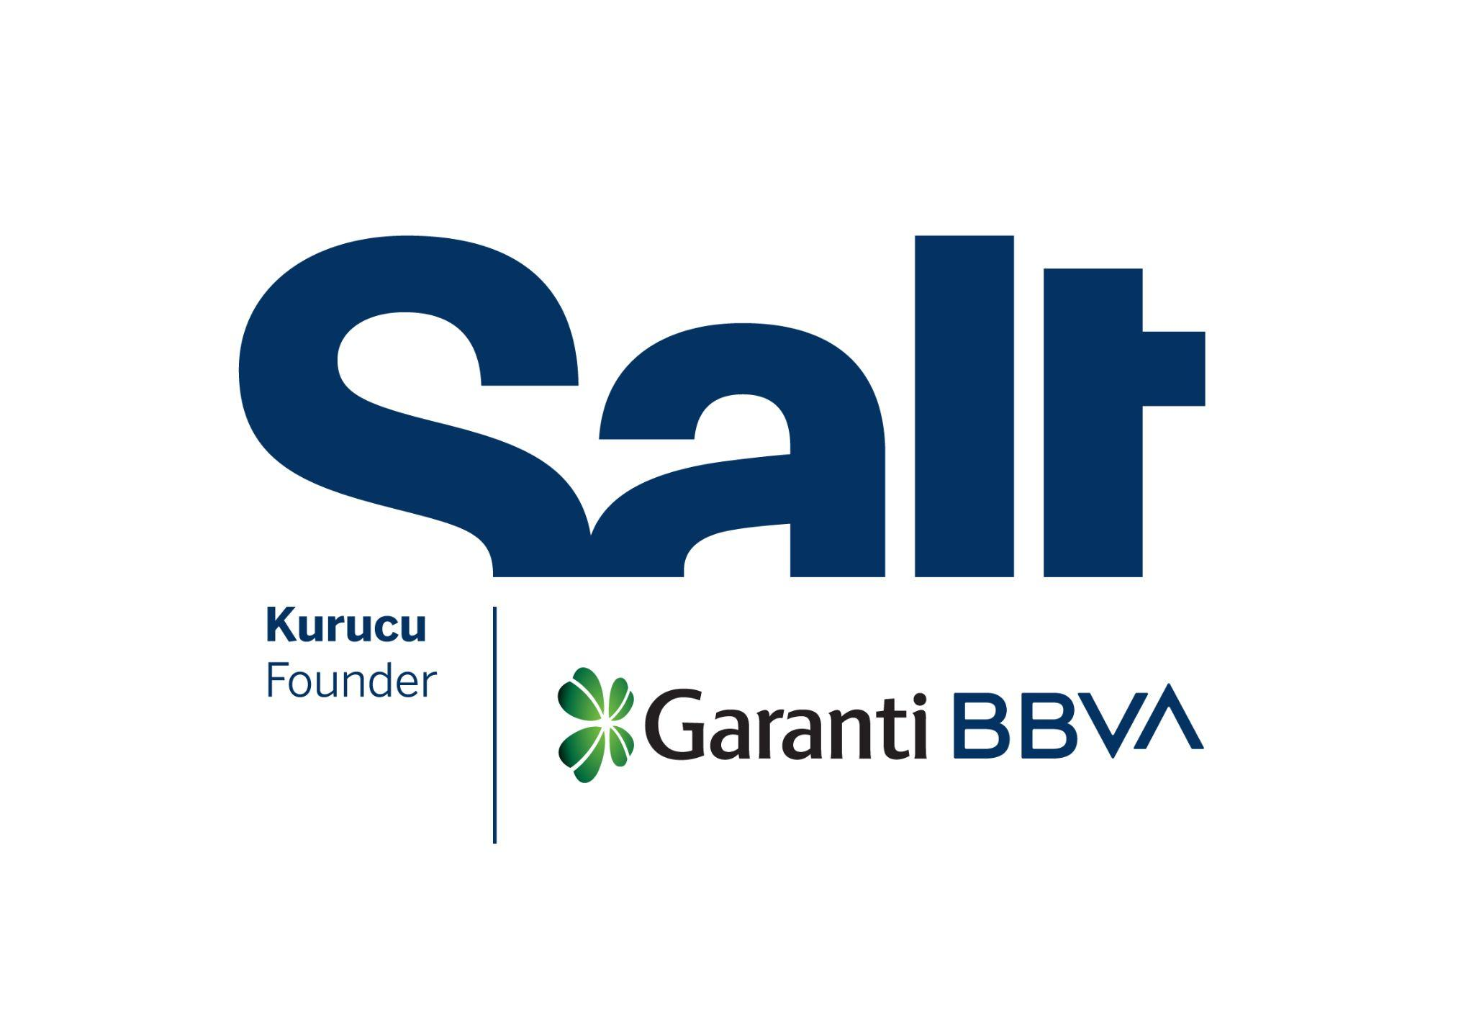

Press Release
April 2, 2026

Exhibition: Subsoil
Onur Gökmen

April 2 – May 3, 2026
Salt Galata

Onur Gökmen’s exhibition “Subsoil,” supported in 2025–2026 as part of the Salt Artistic Research and Production Grant Program, in collaboration with the BBVA Foundation, opens at Salt Galata.

Salt presents Subsoil by Onur Gökmen, one of the two recipients of the second edition of the Salt Artistic Research and Production Grant Program, organized in collaboration with the BBVA Foundation.

The exhibition revisits a largely overlooked episode in the environmental and institutional history of Turkey: the detection of radioactive contamination in Black Sea tea following the 1986 Chernobyl disaster.

In the aftermath of the explosion at the Chernobyl Nuclear Power Plant, a team of scientists at Middle East Technical University (METU)—including the artist’s parents, İnci and Ali Gökmen—conducted a study to measure the impact of radioactive fallout on tea grown in the Black Sea region. The findings were compiled in a report and submitted to the relevant authorities. Yet, official statements tended to minimize the extent of the contamination and health risks, reflecting concerns over economic and social stability. Amid discussions around public health and accountability, the METU report eventually leaked to the press. While news coverage—often addressing the issue through mediatized images and headlines—generated a degree of public awareness, institutional responses remained largely unchanged, even as contaminated tea stayed in circulation. Sensational statements—such as “radioactive tea tastes even better” or “a little radiation is good for the bones”—overlooking the effects of radioactive contamination, along with images of state officials drinking tea, lingered in the collective memory. Meanwhile, tea became both a material witness to imperceptible radiation and a carrier of nuclear anxiety.

Staging three fragments from this major episode in Turkey’s nuclear history, the exhibition establishes a dialogue between narrative and evidence by blending fictional and documentary elements. The first part features a spatial fragment from METU, where the contamination in tea was first identified, alongside a documentary based on the account of İnci and Ali Gökmen. Set in a television studio, the second section reflects the intertwined relationships between media, state apparatuses, and bureaucracy. At the center of this installation is a short film inspired by news reports that construct a fictional image of the Black Sea while downplaying the level of radioactive material in the tea. Situated behind these two sets, the final part comprises photographs that seep through them, capturing the traces of the Chernobyl disaster in Turkey.

Tracing the movement of radiation through natural and institutional systems, these three scenes reveal how environmental harm—though invisible and slow—has shaped public health, policy, and societal narratives. They also suggest that radiation can never be fully consigned to the past: it belongs neither to a single generation nor to a specific geography. Just as radiation carried by clouds and seeping into the ground is transmitted to the present through the soil, the images of this incident continue to circulate in personal and collective memory.

The exhibition is ​​on view in the Mastercard Exhibition Hall at Salt Galata until May 3. For more information: saltonline.org.

The exhibition is realized with the contributions of Eureko Sigorta and Jotun.

***

Program: Gülce Özkara
Design and Production: Emirhan Altuner
Editor: Ezgi Yurteri
Production Assistant: Fulya Aras
Installation: Eray Özcan, OCD Museum Works
Communication Design: Okay Karadayılar
Salt Artistic Research and Production Grant Program Coordinator: Alâ Taleb
Acknowledgments: Ali Gökmen, İnci Gökmen, Olcay Birgül, Aykut Kence, Dilara Çatak, Damla Kırkalı, Sara Pınar Önder, Dilara Tığlı, Can Candan, ODTÜ, Kulturakademie Tarabya, Hessische Kulturstiftung

Founded by Garanti BBVA, Salt is a not-for-profit cultural institution engaging in research, exhibitions, publications, web projects, and public programs at the intersections of visual practices, the built environment, social life, and economic history.

The BBVA Foundation, as the corporate social responsibility of the BBVA Group, is committed to advancing society by promoting and disseminating knowledge through research-based, artistic, cultural, and scientific projects.

Media Relations
Zeynep Akan
zeynep.akan@saltonline.org
+90 212 334 22 45

