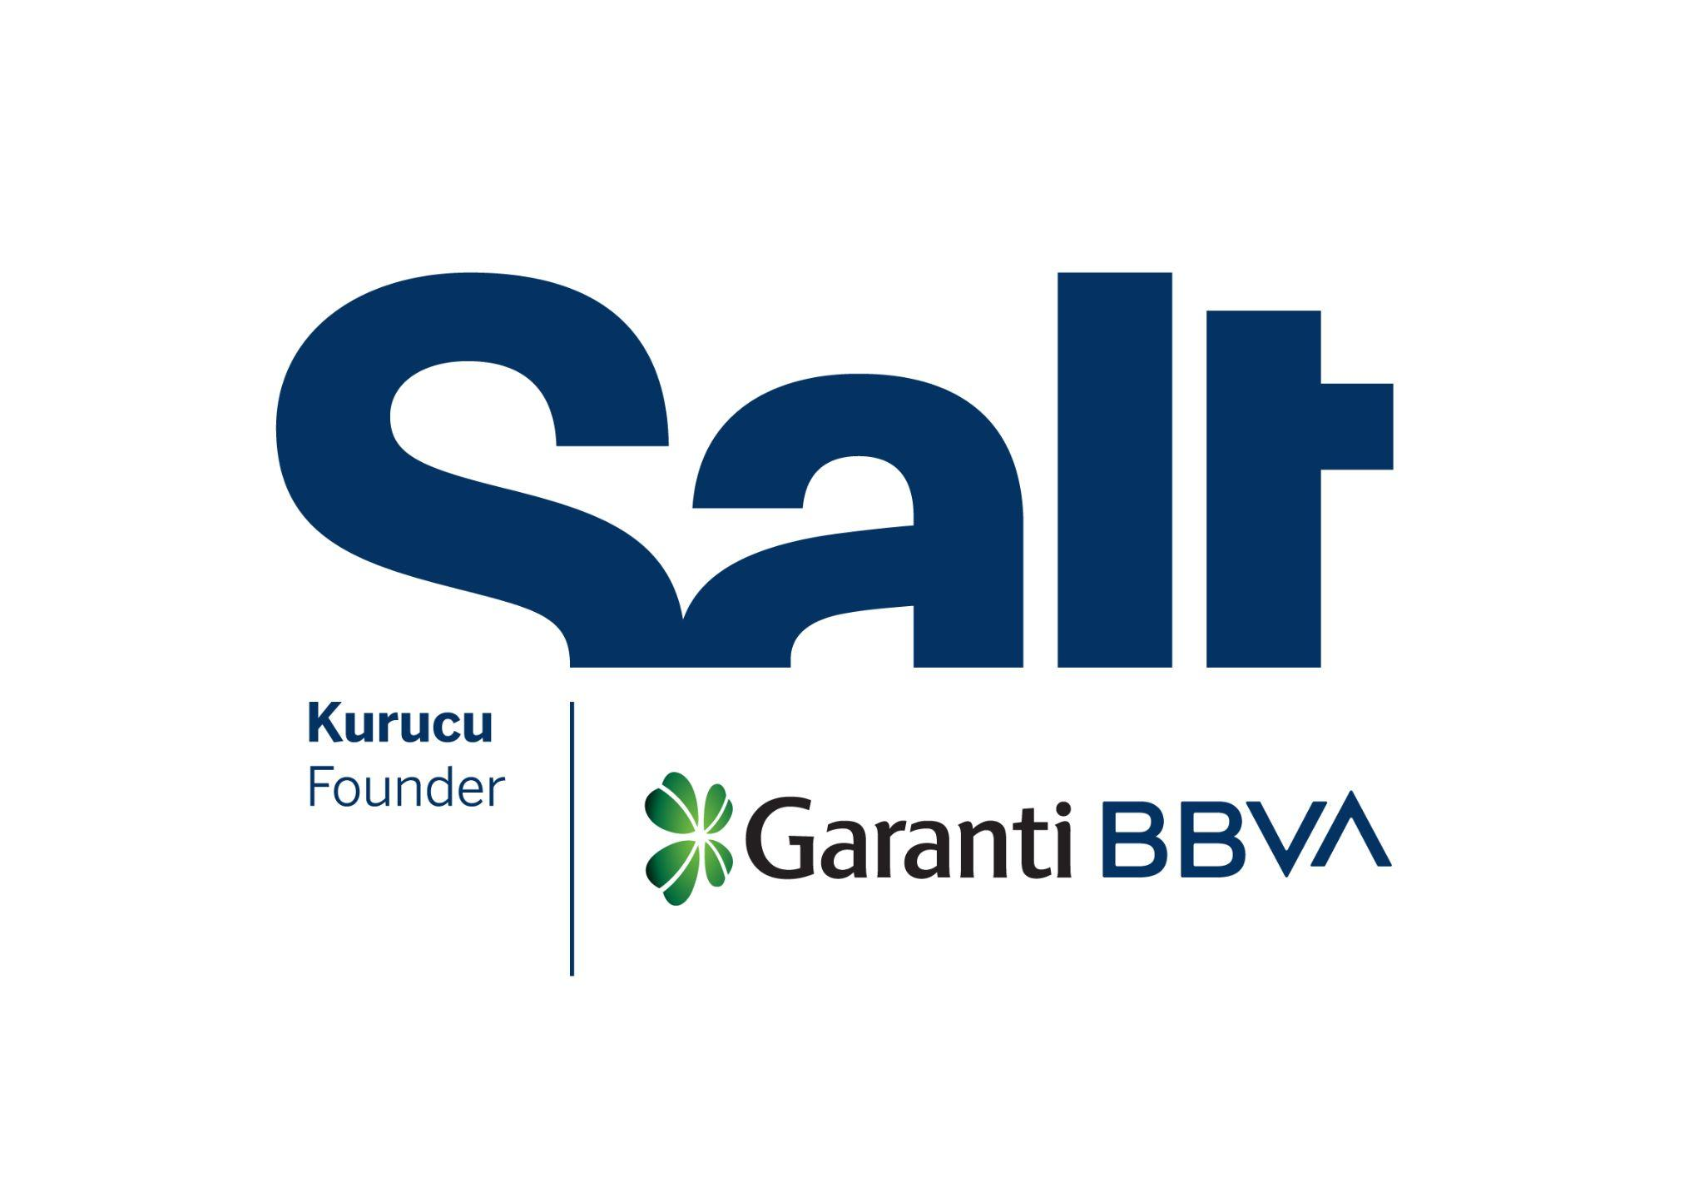

Press Release
March 10, 2026

New Program:
Trash

March 10 – April 12, 2026
Salt Beyoğlu

“Trash” begins at Salt Beyoğlu, exploring exhibition-making processes and design practices through objects left behind from previous Salt exhibitions.

“Are pedestals or display cases only meant to hold artworks? Does their life end when the exhibition closes, or can they assume different roles with each use—becoming both support structures and design objects in their own right?”

Founded by Garanti BBVA, Salt’s new program Trash traces display units produced for its programs and repurposed on various occasions. Exploring material decisions within exhibition-making processes, it offers a multilayered perspective on scenography and design practices through objects left behind from past exhibitions. Drawing on the institution’s 15-year history, the program opens up a discussion on the circulation of materials from gallery space to storage, the often-invisible exhibition infrastructures, and diverse forms of reuse.

These materials—neither the output of an industrial production line nor readily defined as “waste”—may gradually be written off and come to be considered “trash” while awaiting new functions in storage. Taking this nuance between waste and trash as a point of departure, the program underscores that value is not inherent in the material itself, but rather emerges from the context in which it is used and the meanings attributed to it. By assembling a pile of materials, the installation sets a stage that reveals the transience and mutability of this context, while also highlighting the exhibitionary conventions shaped by institutional decisions.

Transforming Salt Beyoğlu’s ground floor into a production space, where materials such as wood, glass, plexiglass, metal, foam, and paper are sorted, modified, and repurposed, Trash shows that discarded materials also carry memory and can hold archival qualities. Accompanied by workshops and talks on exhibition design practices, it revisits existing productions from new perspectives to develop proposals in dialogue with the space.

The program will continue until April 12 on the ground floor of Salt Beyoğlu and will be accompanied by a series of talks. For more information: saltonline.org.

The program is realized with the support of Jotun.

***

Program: Emirhan Altuner
Advisor: Can Altay
Workshop Facilitator and Advisor: Ahmet Sertaç Öztürk
Editor: Ezgi Yurteri
Program Assistants: Fulya Aras, Ayşe Bıçak
Installation: OCD Museum Works, Maksu Reklam

Salt is founded and supported by Garanti BBVA.

Media Relations
Zeynep Akan
zeynep.akan@saltonline.org
+90 212 334 22 45

