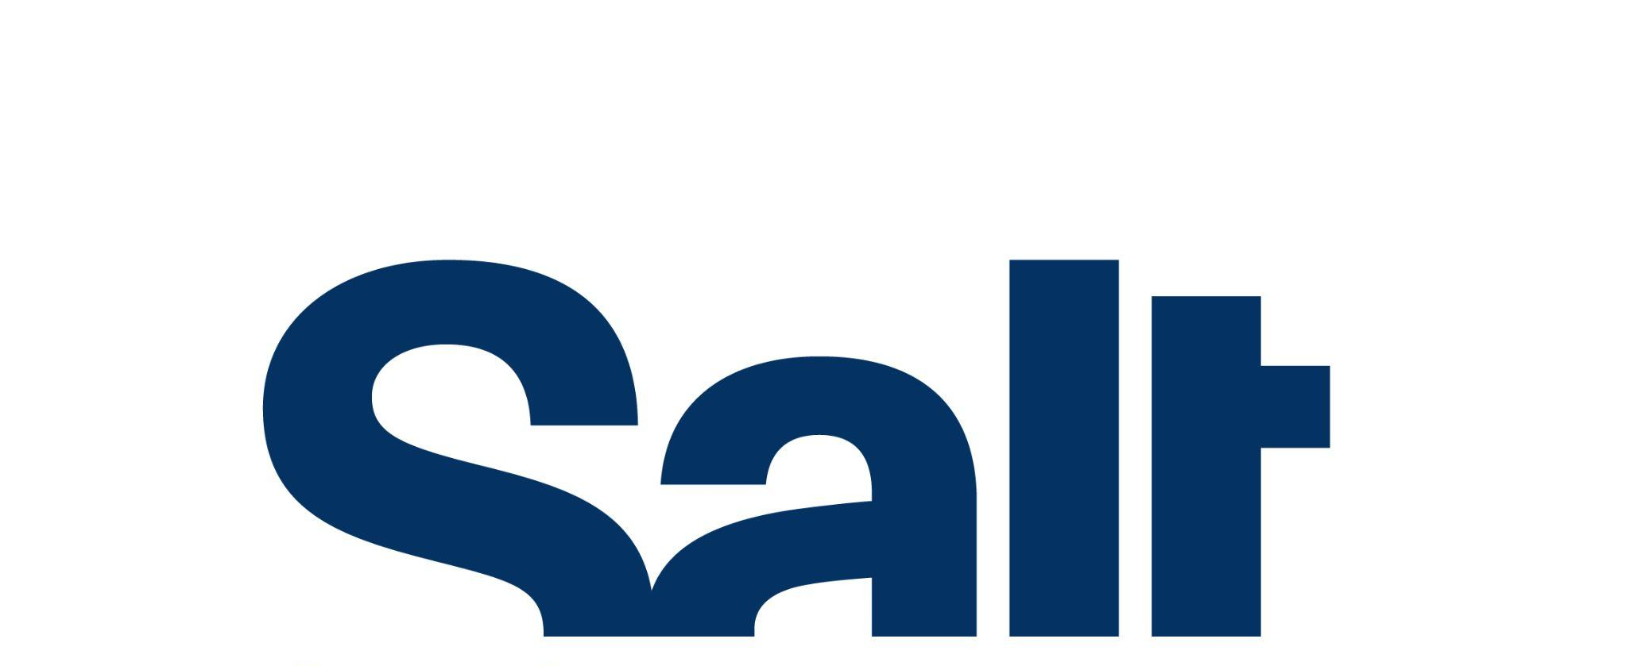

Press Release
April 22, 2026

Exhibition:
Breaking Through a Dam

April 22 – August 23, 2026
Salt Beyoğlu

Tracing the relationships between landscape, memory, and archive across a geography spanning from the Eastern Mediterranean to the Gulf region, “Breaking Through a Dam” is now on view at Salt Beyoğlu.

Salt’s new exhibition Breaking Through a Dam reflects on forms of “being‑with‑place” beyond colonialist practices in a geography spanning from the Eastern Mediterranean to the Gulf region through a selection of works. It envisions a collective ground for existing, in pursuit of transgeographical solidarities and experiences of shared historical trajectories that reach beyond nation‑states.

The exhibition centers on the relationship between landscape, memory, and archives in the formation of this shared ground: Dams, canals, oil wells, geothermal plants, surveillance systems, and cell towers not only transform the surrounding terrain; they also reshape the cultural and social bonds forged around them. Yet collective memory does not cease to exist; rather, it becomes inscribed onto the landscape. Rivers, wetlands, streets, and coffeehouses each serve as an archive that holds this memory.

Taking its title from human rights lawyer Noura Erakat’s statement, “We are breaking through a dam—keep pushing,” the exhibition situates infrastructures not only as instruments of control but also as metaphors for what seeps through and resists. Memory seeps into the present through cracks, like a seemingly tranquil river that overflows without warning. Even as the landscape foregrounds ownership, domination, and resource extraction, it also harbors practices of remembrance, togetherness, and “being‑with‑place.”

The remnants of a colonialist “inland sea” project in the Sahara, the invisible terrain of telecommunication networks, lights seeping from an abandoned nightclub, and the sound of sinkholes collapsing centuries of destruction into mere seconds intermingle within the exhibition space. From the desert routes charted by a former intelligence officer to delineate the energy map of Western Asia, to the traces left behind by nuclear catastrophes; from the landscapes carried in the memories of workers migrating to Europe, all the way to the persistent roots of cacti redrawing the borders of destroyed Palestinian villages, myriad narratives come together on a shared ground.

Programmed by Gülce Özkara from Salt, Breaking Through a Dam is on view at Salt Beyoğlu until August 23. Public programs accompanying the exhibition will be announced soon. For more information: saltonline.org.

Artists: Haig Aivazian, Monira Al Qadiri, Al-Wah’at Collective, Mehmet Ali Boran, Can Candan, Aslıhan Demirtaş, Alia Farid, Metincan Güzel, Emre Hüner, Evrim Kaya, Yelta Köm, Fredj Moussa, Dima Srouji, Aslı Uludağ, Merve Ünsal

Breaking Through a Dam is realized with the support of the Kingdom of the Netherlands and Feltouch and with contributions from Asya International Movers, Bankerhan Hotel, Eureko Sigorta, and Jotun.

***

Program: Gülce Özkara
Exhibition Design and Production: Emirhan Altuner
Editor: Ezgi Yurteri
English Translation: Çağla Özbek
Design and Production Assistant: Fulya Aras
Installation: Mustafa Kurt, Eray Özcan, OCD Museum Works, 3T Reklam
Communication Design: Amir Jamshidi
Acknowledgments: Derin Print Shop, Dou Print Studio, KÖNIG GALERIE, Sfeir-Semler Gallery

Media Relations
Zeynep Akan
zeynep.akan@saltonline.org
+90 212 334 22 45

