THE SEQUENTIAL I

LOCUS OF POWER
Barış Doğrusöz

January 19 - March 28, 2021
SALT Galata

Until the time is right the only way to preserve what we discover is to bury it under the sand...*

Early in 1920, British troops digging trenches around the Euphrates River discovered a fresco in their camping area. The following archaeological expeditions unearthed Dura-Europos, later known as the “Pompeii of the Syrian desert,” which was lost from sight for seventeen centuries. An area of interest and research for artist Barış Doğrusöz since 2017, the Locus of Power trilogy examines the culture as well as the economic and political history of the ancient city located in Deir ez-Zor. Presented for the first time as part of The Sequential program, the multimedia installation based on the reconstruction of the site looks at the aesthetics of ruins, representation and rereading of colonial discourse on the basis of museology and archeology.

The first video of the trilogy, Sandstorm and the Oblivion (2017) traces the siege, decline and unearthing of the city, which was originally named Dura, meaning “fortress” by its first inhabitants, and Europos by the Greeks. Doğrusöz contextualizes the ruins somewhere between fact and fiction, scrutinizing the act of digging in literal and figurative terms. Building on the reports by French and American archaeologists, satellite images and footage from within the city walls, the work registers the past and ongoing conflicts in these lands where excavations function as “instruments of soft power politics.”

Beneath Crowded Skies (2019) draws attention to the periodic sieges that the fortress town has been subjected to for centuries, whether through the scientific process or the military operations and militant attacks in the region over the past decade. The artist refers to the graffiti left by “natives and foreigners, soldiers and civilians who lived, loved, danced, laughed, traded, and fought in the Fortress,” inside and outside the buildings as in public and private spaces. The circular structure that he creates while compiling the information and the refrain included in the text allows him to construct a spiral of conflict and struggle linking ancient history to the present.

Completed in 2020 for The Sequential, Cross-Pollinated questions the observability of archaeological sites as a cultural heritage. Doğrusöz focuses on the footage of the Corona spy satellite, operated by the United States from 1959 to 1972 for photographic surveillance of the Soviet Union and the People’s Republic of China as well as the West Asian territories where they were active at the time. The historic aerial and satellite images, which were declassified in 1992, document the destruction of the ancient city. The artist expands his research by pointing out the issues of water politics and energy resources, reclamation, urbanization, wars, systematic looting and deliberate destruction, which all are decisive for the present-day conditions of the region.

Locus of Power by Doğrusöz, whose practice reconstructs and interprets the data defining the collective memory by exploring places, temporalities and systems that shape the narrative of history, is on view on floor -1 at SALT Galata until March 28. Online public programs to be organized in parallel to the presentation will be announced at saltonline.org.

* Excerpt from Sandstorm and the Oblivion (2017) as part of the Locus of Power video trilogy by Barış Doğrusöz

Featuring five independent presentations by Barış Doğrusöz, Deniz Gül, Volkan Aslan, Aykan Safoğlu, and the duo Fatma Belkıs & Onur Gökmen, The Sequential program will take place at SALT Galata throughout 2021.

Supported by SAHA, The Sequential will be included in the 2021-2022 public programs of
three member institutions of L'Internationale—Museo Nacional Centro de Arte Reina Sofía (Madrid), Muzeum Sztuki Nowoczesnej w Warszawie (Warsaw) and M HKA, The Museum of Contemporary Art (Antwerp)—following the initial presentations at SALT Galata.

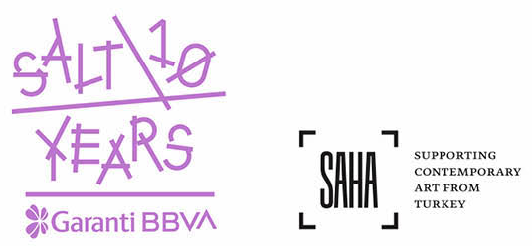

IMAGES

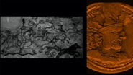
1.
Still from Sandstorm and the Oblivion (2017) as part of the Locus of Power video trilogy by Barış Doğrusöz
Courtesy the artist

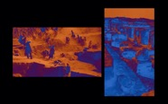
2.
Still from Beneath Crowded Skies (2019) as part of the Locus of Power video trilogy by Barış Doğrusöz
Courtesy the artist

Media Relations
Zeynep Akan zeynep.akan@saltonline.org +90 212 334 22 45

