THE SEQUENTIAL

Featuring exhibitions by Barış Doğrusöz, Deniz Gül, Volkan Aslan,
Aykan Safoğlu, and Fatma Belkıs & Onur Gökmen, The Sequential program
will take place at SALT Galata throughout 2021.

An outcome of studio visits and open dialogue initiated in 2019 at the invitation of SALT, The Sequential features five independent exhibitions by Barış Doğrusöz, Deniz Gül, Volkan Aslan, Aykan Safoğlu, and the duo Fatma Belkıs & Onur Gökmen. As artists coming from the same generation, the fresh visual and conceptual vocabulary emerging in their practice is rooted in the recollections and common sensibilities from the last twenty-five years.

The works in The Sequential look into the notion of “symbolic power” through the exploration of historiography, language, public sphere, symbolic capital, and modernization. The program aims to provide a wider space for expression for each artist, rather than adopting the traditional setting of a collective exhibition and comparison space. In 2021, which marks the tenth year of SALT, it also opens up an opportunity for closer creative exchange with artists with whom the institution has previously engaged in only limited collaborations.

The extraordinary circumstances, which are now at the forefront of the world’s attention, had not yet occurred during the early stages of the program, but the following period paved the way for a number of long overdue questions to be articulated on how to develop sustainable and relevant forms of “display.” The critical importance of deliberations between artists and cultural establishments have been highlighted in the extended conversations. In this context, The Sequential serves as an exemplary model not only for taking on an approach based on collaborative effort, but also for the role of institutional support in the production of new creative works during times of crisis.

The Sequential is programmed by Amira Akbıyıkoğlu and Farah Aksoy from SALT. Further information about the past and current exhibitions as well as the parallel online programs is available at saltonline.org.

Supported by SAHA, The Sequential will be included in the 2021-2022 public programs of
three member institutions of L'Internationale—Museo Nacional Centro de Arte Reina Sofía (Madrid), Muzeum Sztuki Nowoczesnej w Warszawie (Warsaw) and M HKA, The Museum of Contemporary Art (Antwerp)—following the initial presentations at SALT Galata.
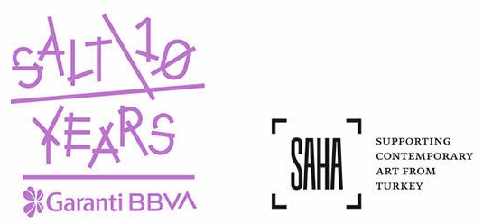

IMAGES

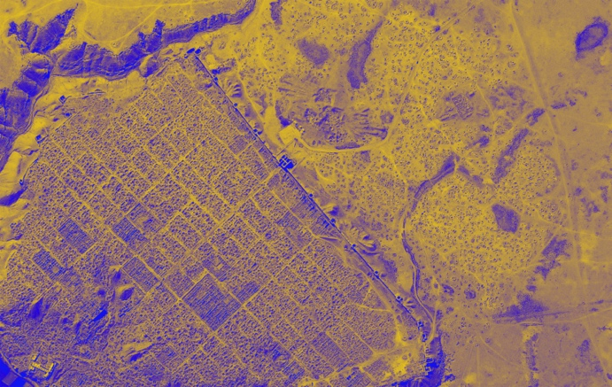
1.
Image from Barış Doğrusöz’s research for the video trilogy Locus of Power (2017-2020)
Courtesy the artist

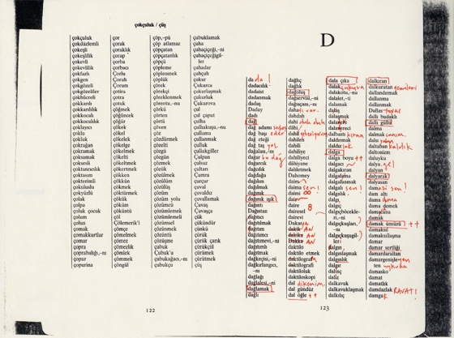
2.
“D” from the series Klavuz [Plungr] (2016-2021) by Deniz Gül
Courtesy the artist

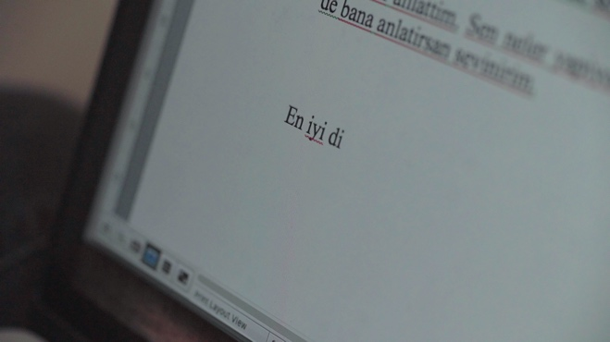
3.
Still from the video En İyi Dileklerimle [Best Wishes] (2019) by Volkan Aslan
Courtesy the artist

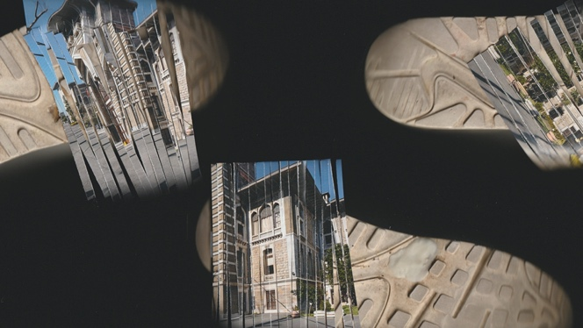
4.
Still from the video Hundsstern steigt ab [Dog Star descending] (2020) by Aykan Safoğlu
Courtesy the artist and The Pill (Istanbul)

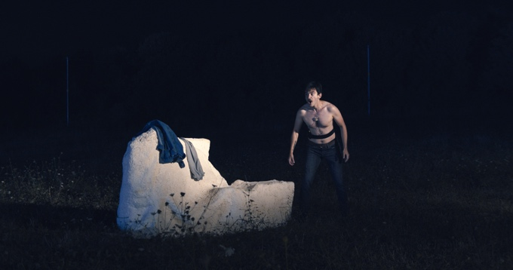
5.
Still from the in-progress film Alakadar [The Connected] by the duo Fatma Belkıs & Onur Gökmen
Courtesy the artists

Media Relations
Zeynep Akan zeynep.akan@saltonline.org +90 212 334 22 45

