THE SEQUENTIAL

SALT Galata
January 2021 - January 2022

Presentations by Barış Doğrusöz, Deniz Gül, Volkan Aslan,
Aykan Safoğlu, and Fatma Belkıs & Onur Gökmen

An outcome of studio visits and open dialogue initiated in 2019 at the invitation of SALT, The Sequential features five independent presentations by Barış Doğrusöz, Deniz Gül, Volkan Aslan, Aykan Safoğlu, and the duo Fatma Belkıs & Onur Gökmen. The six mid-career artists included in the year-long program are united by “generational ties,” a shared experience of growing up in the 1980s and the 1990s. The fresh visual and conceptual vocabulary emerging in their practice is rooted in the recollections and common sensibilities from the last twenty-five years.

The works in The Sequential look into the notion of “symbolic power” through the exploration of historiography, language, public sphere, symbolic capital, and modernization, respectively. The program aims to provide a wider space for expression for each artist, rather than adopting the traditional setting of a collective exhibition and comparison space. In 2021, which marks the tenth year of SALT, it also opens up an opportunity for closer creative exchange with artists with whom the institution has previously engaged in only limited collaborations.

The extraordinary circumstances, which are now at the forefront of the world’s attention, had not yet occurred during the early stages of the program, but the following period paved the way for a number of long overdue questions to be articulated on how to develop sustainable and relevant forms of “display.” The critical importance of deliberations between artists and cultural establishments have been highlighted in the extended conversations. In this context, The Sequential serves as an exemplary model not only for taking on an approach based on collaborative effort, but also for the role of institutional support in the production of new creative works during times of crisis.

Programmed by Amira Akbıyıkoğlu and Farah Aksoy from SALT, The Sequential will commence at SALT Galata on January 19, 2021 with the first spatial presentation of Barış Doğrusöz’s video trilogy Locus of Power, a work in progress since 2017. The details of Locus of Power, which continues until March 28, as well as further information about the upcoming online workshops and screenings in parallel to the presentation will be announced at saltonline.org.

Supported by SAHA, The Sequential will be included in the 2021-2022 public programs of three member institutions of L'Internationale—Museo Nacional Centro de Arte Reina Sofía (Madrid), Muzeum Sztuki Nowoczesnej w Warszawie (Warsaw) and M HKA, The Museum of Contemporary Art (Antwerp)—following the initial presentations at SALT Galata.

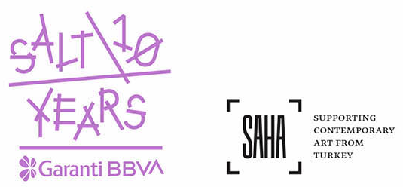

Media Relations
Zeynep Akan zeynep.akan@saltonline.org +90 212 334 22 45

